6.26-7.2 testing report

1. Changed copyright to 2021

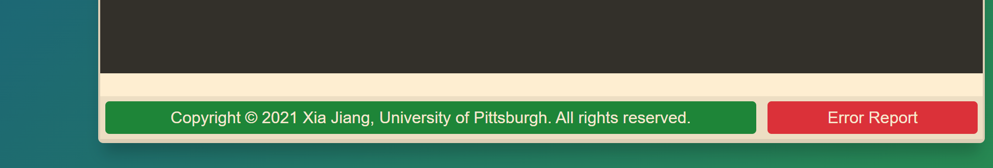

Fig.1

2. I have updated the 10-year and 15-year alcohol usage patterns.

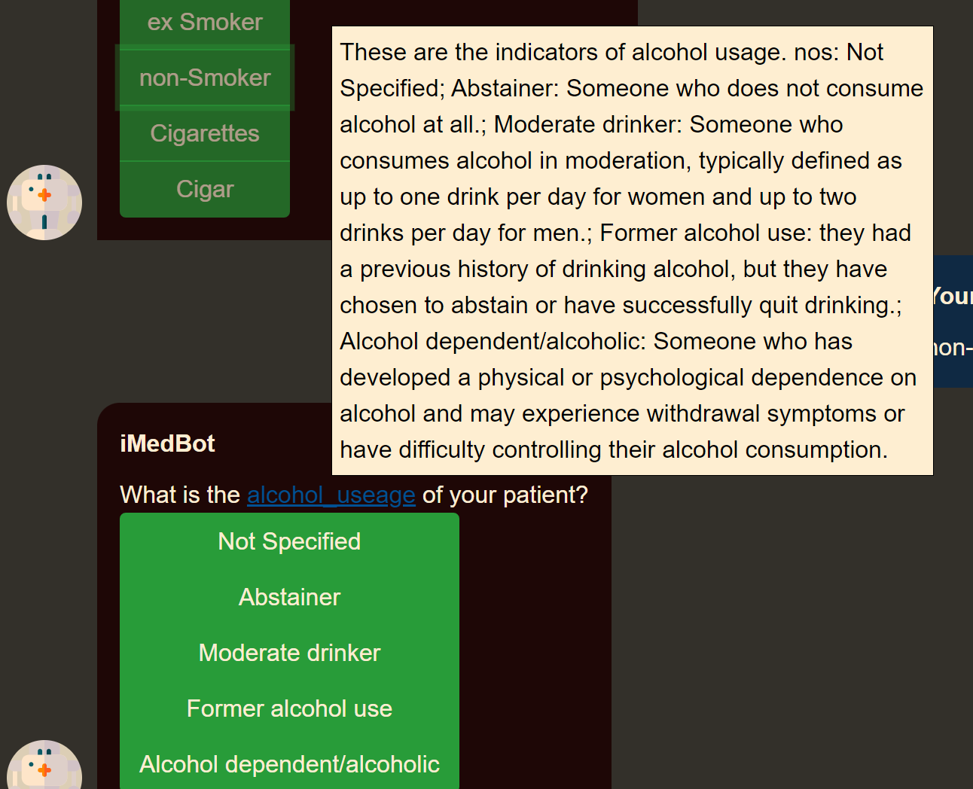

Before After

3.